Fanatics Sportsbook Promo Test Plan
Lids Sports Group
7676 Interactive Way
Indianapolis, IN 46278
July 13, 2023

Prepared By:
Tim Powers

Overview
Fanatics Betting & Gambling (FBG) has a unique opportunity to partner with Lids Sports Group. Lids currently has 1200+ retail locations across the US, most of which are located within shopping malls. FBG and Lids leadership believes there is an opportunity to cross-sell between businesses [drive foot traffic to Lids locations and increase awareness for Fanatics Sportsbook].

High Level Requirements

 | Requirement | Epic/Feature/Story/Bug Link(s)
Approvals | Statement of Work  Test Plan | FBG Responsible  ADO #29712
Hardware | Android 12.0 or higher  iOS 15.0 or higher  Standard issue laptop | No ADO write-up required
Software | D365 Test Environment  FBG Google Account  VPN  Twingate App  Firebase (Android) App  TestFlight (iOS) App  BetFanatics Test App (App tester) | FBG Responsible

Data workflow and dependencies
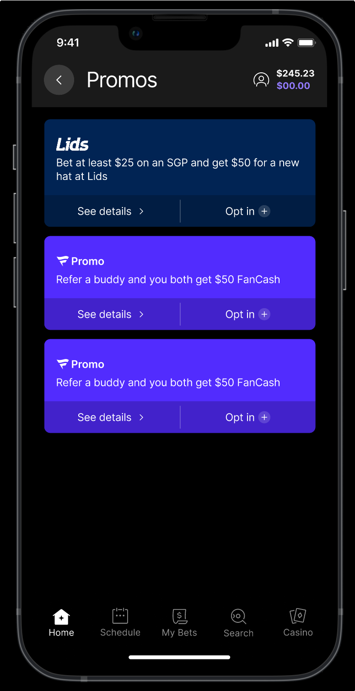
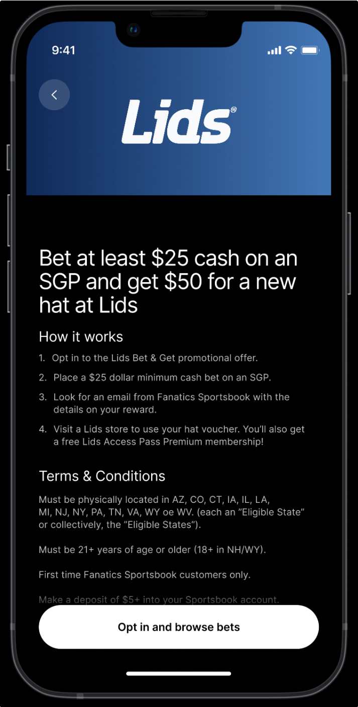

Internal Dependencies

Gift card vouchers - Lids will supply FBG with a “bucket” of codes to associate with a player
Closed test store – Production store 0002 register 03 (0002-03)

External Dependencies – Fanatics Betting & Gambling Development Team

Accesses for Twingate / App Tester / Fanatics Sportsbook applications

Project coordination handled by Fanatics Betting & Gambling

Scope

In Scope:

Android, iOS, & PAX devices
Testing Lids Gift card in Store

Out of Scope:

Devices - the following devices are not included in the Day 1 launch on this feature:
- Tablets
- iPads
- Laptops
- Devices on iOS versions less than 15.0
- Devices on Android versions less than 12.0
- Kiosk
- Retail

Gift card usage in countries outside of United States

Existing Access Pass Free & Premium customers

Accessibility

Test Strategy

Functional Testing

 | Feature | Test Scenarios | Lids?
1 | Promos | Lids Offer on Promo Page | Yes
2 |  | Offer Details and T&Cs | Yes
3 |  | Promo card expires 12/31 | Yes
4 | Optimove | Bonus Action Events | No
5 |  | Each Promo criteria | No
6 |  | All Promo Criteria | No
7 | Bet | All Cash Bet types are supported | Yes
8 | Post Bet | Bet must be settled to get the offer | Yes
9 |  | Cashout/Cancelled bet will not receive the offer | Yes
10 | Email | Lids Voucher/Gift card to email | Yes
11 |  | Redemption is 30 days | Yes
12 | Toast/Banner | Banner in FBG App when user receives the offer | Yes
13 | Prod Testing | Prod testing with Auto bet settling instead of manual settling | Yes

Regression Testing

At this time, all Functional testing will be included in Regression testing (see above). As the product/functionality stabilizes, we will prioritize test cases to narrow down for a regression test suite.

Compatibility Testing
Devices
App Version | OS Versions | Device Versions
1.0.0 | 15.0, 16.0 | iPhone 11 & up
1.0.0 | 12.0, 13.0 | Compatible Android device

Manual vs Automation Strategy

Initial sign-off will be executed manually. Will integrate automated regression suites in tandem with test case execution.

Accessibility Testing TBD

Latency Testing

TBD

Test Data

All created test accounts added to Promo

Defect Management

Issues will be logged in Azure DevOps to the epic as bug tickets. The bug tickets will be reviewed by the QA/Product Owner team(s) and assigned priority and severity. The bug will be triaged, and QA/Product Owner team(s) will collaborate with development teams to address bug in specified timeframe.

Status Reporting
Status reports will be sent out after the final phase is completed and will be setup as a dashboard using Azure DevOps. The following will be reported:
Lids Test Plan

Completion (% complete, % passed, % failed, % blocked) Plan will include results for:
iOS testing
Android testing Bugs Logged

Entrance and Exit Criteria Entrance Criteria:
No. | Description | Status
1 | Requirements have been delivered and reviewed | Completed
2 | All stories in associated epics are complete before associated phase. | In Progress
3 | Optimove work for Lids Offer | Completed
4 | Test data is created | Completed

Exit Criteria:

No. | Description | Status
1 | All scheduled test passes have been completed | In Progress
2 | Must have 100% workflow/scenario coverage in UI tests before release | In Progress
3 | All testing phases are complete | In Progress
4 | All integration tests must be passing 100% in pipelines before feature is released to customers in production | In Progress
5 | Create a Regression suite | In Progress
6 | QA has reviewed and signed off on all testing activities | Not Started

Risk Analysis
Identify any potential concerns/risks to delivery and planned mitigation actions

Risk | Likelihood | Impact | Mitigation
New feature | High | Because this is a new feature, it’s possible we’ll see the feature break or change as other features are implemented | Regression will be important in identifying bugs earlier and working with the development teams to understand the impact of other features
High number of dependencies | High | The feature will appear on the Discover page and the Search Landing Page, it’s possible that the feature could be impacted with each additional dependency | Communication with development teams to determine how features are intertwined and affected by each other
Tight timeline for Functionality signoff | High | Given the turnaround time needed for GLI, we need to sign off functionality by end of July | Regular regression passes to sign off on this feature functionalities early to give handoff to regulatory team. Work with TPM/SEM/PM to have a code freeze timeline
Cross organization contamination | High | FBG is developing all features with the intention said features will work in Lids stores/back-end. Gift cards might not work as expected | Frequent touch bases to communicate issues / questions / concerns to the BFG team.

Release Strategy

Involved Services / Pipelines

TBD

Deployments
TBD. Will update as soon as deployment strategies are finalized

Rollback Strategy
Feature will be rolled out with initial velvet rope release of the FBG application. Rollback strategy to follow that of the initial app release

Testing and release timeline

Activity | Start / End Dates | Owner
Test plan and test cases creation | 7/13 | Quality Assurance
Feature Code Complete | 7/13 | Developer
Full Feature test pass starts | 7/13 | Quality Assurance
UATs | 7/21 | Product Owner
Code Freeze/ Final regression pass | TBD | Quality Assurance
Prod readiness and launch plan review | TBD | Developer
Feature Launch | TBD | Developer

Roles and ownership

Login | Role | Signed Off?
@Adarsh Pandiri | Quality Assurance – Fanatics Sportsbook | No
@Mary Brinkopf | Product Owner – Fanatics Sportsbook | No
??? | Business Representative – Fanatics Sportsbook | No
@Tim Powers | Quality Assurance – Lids Sports Group | No
@Mike Heneghan | Product Owner – Lids Sports Group | No
??? | Business Representative – Lids Sports Group | No

